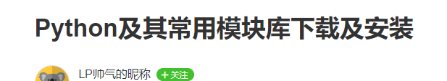
https://www.jianshu.com/p/52eb3df32222

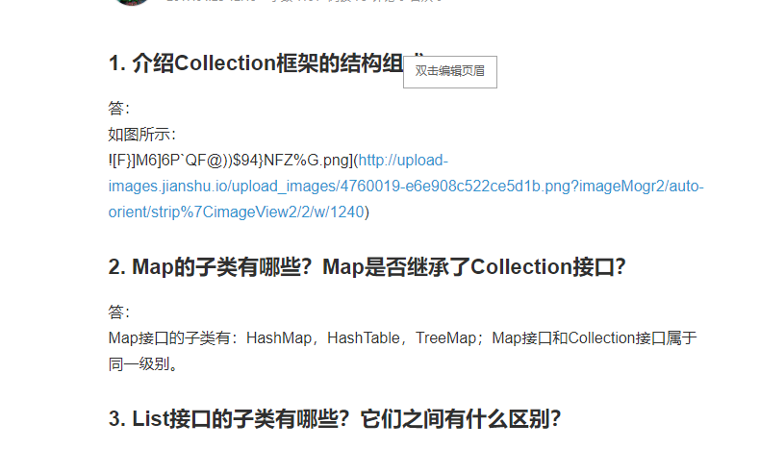
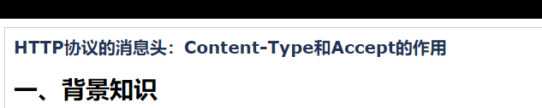
https://www.cnblogs.com/lexiaofei/p/7289436.html?utm_source=itdadao&utm_medium=referral
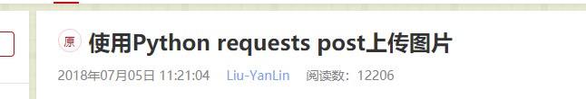
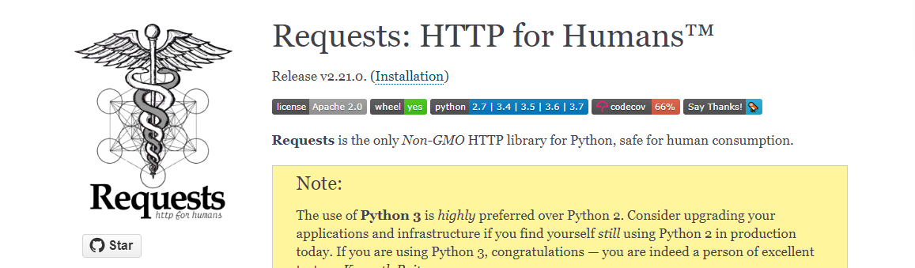
http://docs.python-requests.org/en/master/
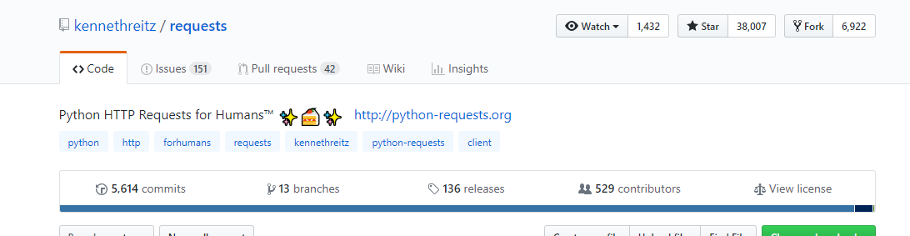
https://github.com/kennethreitz/requests
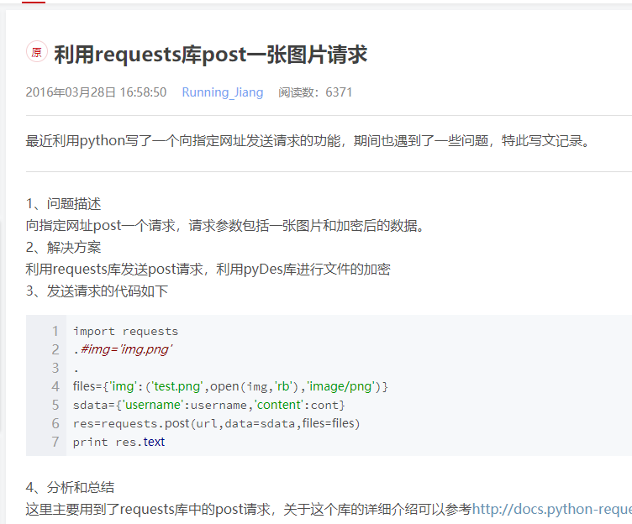
https://blog.csdn.net/Running_J/article/details/50999316
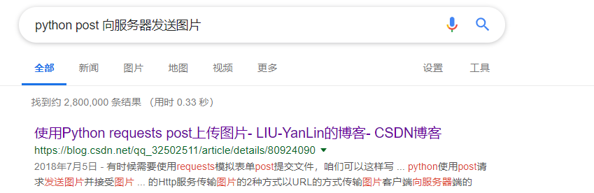
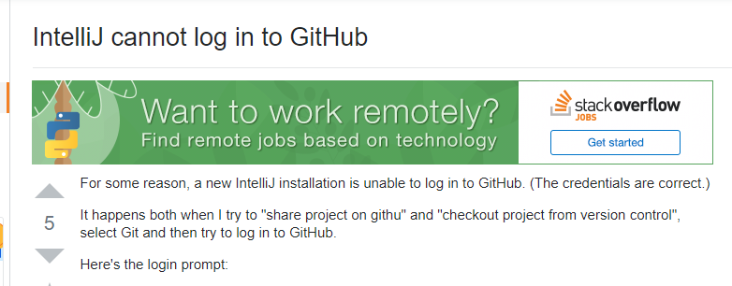
需要验证邮件
